Evolving 8
A monthly digest of best practice educational resources that enhance educator effectiveness
January 2018

Hacking Project Based Learning - Free Online Course

As a Superintendent, I am Gravely Concerned. As a Parent, I am Outraged

Is It The End of Math Homework?

When Does Learning Happen Best? Dan Pink on The Science Behind Timing and Education

Blended Learning Models: Station Rotation

10 Tools to Start a Twitter Chat

Finding a Class to Partner with Virtually and Activities to do Together

Bridging Connections to Empower Learners

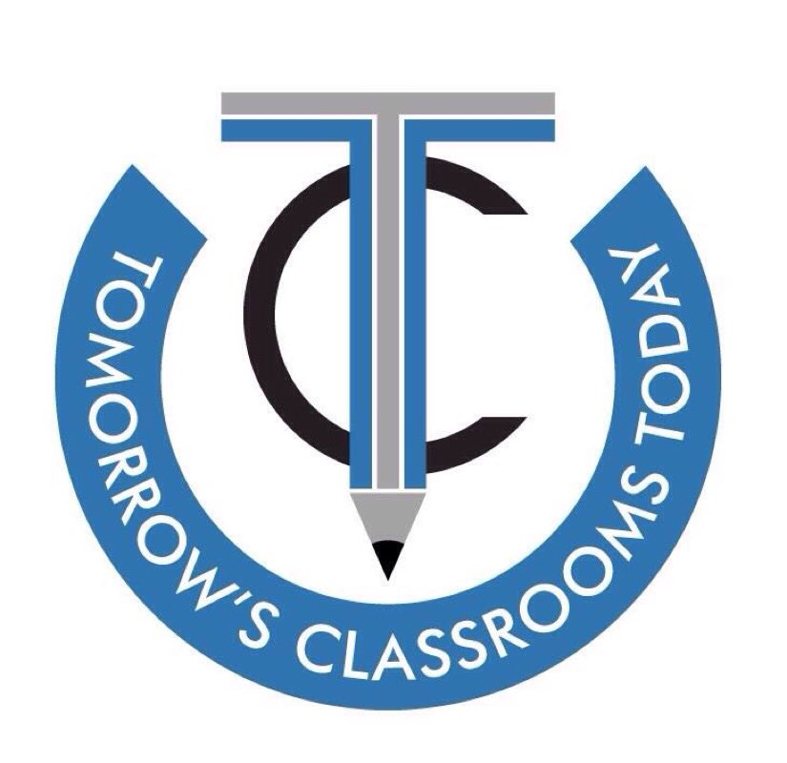

Register for the 4th Annual Tomorrow’s Classrooms Today Conference that is being held on Friday, May 18 and Saturday, May 19 at Rider University in Lawrenceville, NJ. Internationally known keynote speakers Eric Sheninger and Salome Thomas-El will share their insight alongside of 80 other presenters during this two day event. Click here to learn more and register your group at a discounted rate.

